1. 题目

**12558: 岛屿周⻓**

matices, http://cs101.openjudge.cn/practice/12558/

代码：

n,m=map(int,input().split())  
k=0  
sl=[]  
for _ in range(n):  
 sl.append(list(map(int,input().split())))  
for i in range(n):  
 for j in range(m):  
 if sl[i][j]==1:  
 k+=4  
 if i<n-1 and sl[i+1][j]==1:  
 k-=2  
 if j<m-1 and sl[i][j+1]==1:  
 k-=2  
print(k)

代码运行截图 （至少包含有"Accepted"）

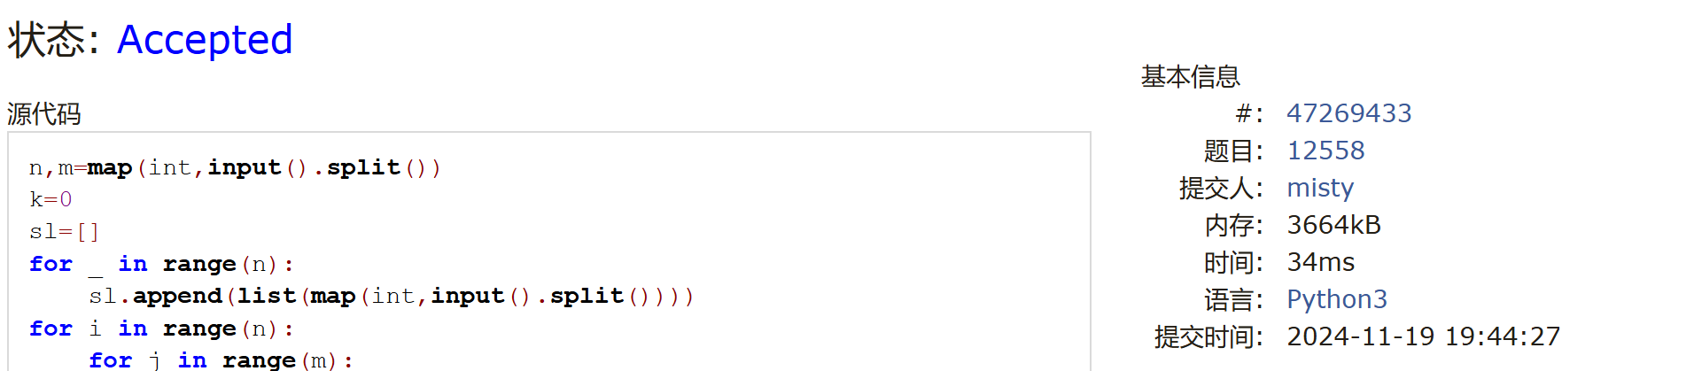

LeetCode54.螺旋矩阵

matrice, https://leetcode.cn/problems/spiral-matrix/

与OJ这个题目一样的

18106: 螺旋矩阵，http://cs101.openjudge.cn/practice/18106

代码：

n = int(input())

matrix = [[0] * n for _ in range(n)]

num = 1

left, right, top, bottom = 0, n - 1, 0, n - 1

while num <= n * n:

for i in range(left, right + 1):

matrix[top][i] = num

num += 1

top += 1

for i in range(top, bottom + 1):

matrix[i][right] = num

num += 1

right -= 1

for i in range(right, left - 1, -1):

matrix[bottom][i] = num

num += 1

bottom -= 1

for i in range(bottom, top - 1, -1):

matrix[i][left] = num

num += 1

left += 1

for row in matrix:

for num in row:

print(num, end=' ')

print()

代码运行截图 ==（至少包含有"Accepted"）==

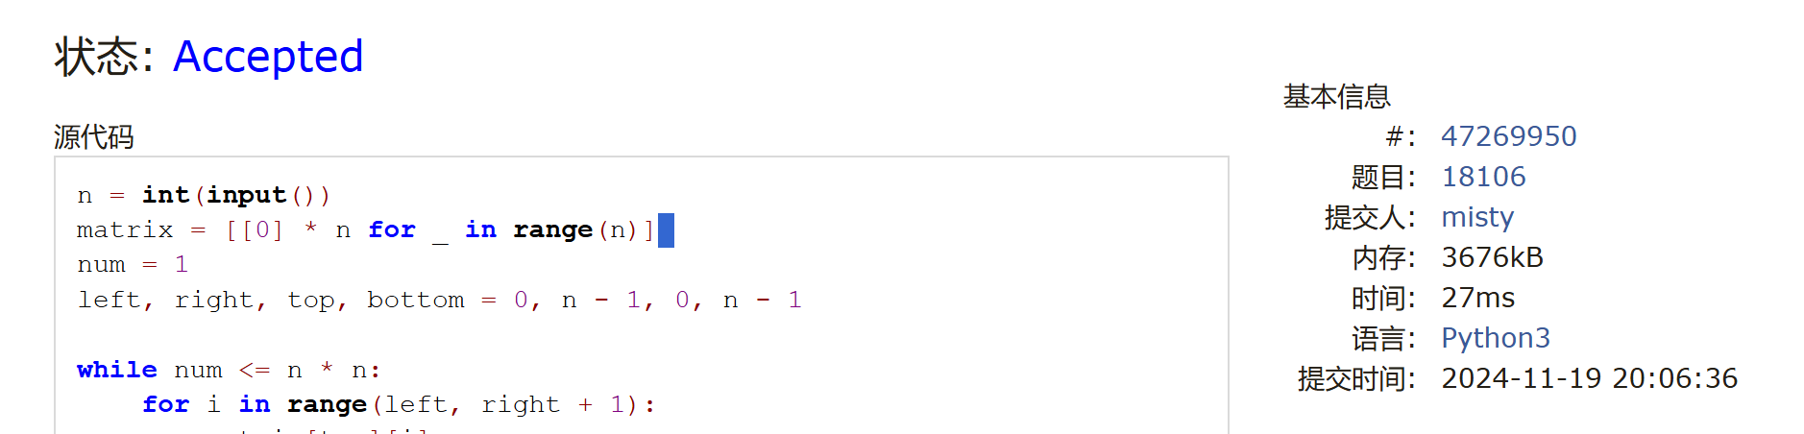

04133:垃圾炸弹

matrices, http://cs101.openjudge.cn/practice/04133/

代码：

d = int(input())

n = int(input())

board = [[0] * 1025 for _ in range(1025)]

for _ in range(n):

x, y, k = map(int, input().split())

for i in range(max(0, x - d), min(1025, x + d + 1)):

for j in range(max(0, y - d), min(1025, y + d + 1)):

board[i][j] += k

maxk = max(max(l) for l in board)

num = sum(l.count(maxk) for l in board)

print(num, maxk)

代码运行截图 （至少包含有"Accepted"）

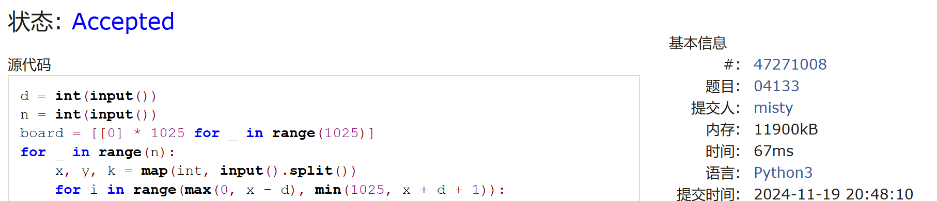

LeetCode376.摆动序列

greedy, dp, https://leetcode.cn/problems/wiggle-subsequence/

与OJ这个题目一样的，26976:摆动序列, http://cs101.openjudge.cn/routine/26976/

代码：

def sgn(x):

if x == 0:

return 0

elif x > 0:

return 1

elif x < 0:

return -1

n = int(input())

nums = list(map(int,input().split()))

delta = [sgn(nums[i+1]-nums[i]) for i in range(n-1)]

result = 1

pre = 0for i in range(n-1):

if delta[i] * pre < 0 or (pre == 0 and delta[i] != 0):

result += 1

pre = delta[i]print(result)

代码运行截图 （至少包含有"Accepted"）

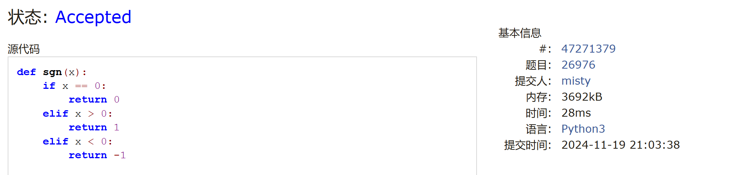

CF455A: Boredom

dp, 1500, https://codeforces.com/contest/455/problem/A

代码：

n,m=map(int,input().split())  
k=0  
sl=[]  
for _ in range(n):  
 sl.append(list(map(int,input().split())))  
for i in range(n):  
 for j in range(m):  
 if sl[i][j]==1:  
 k+=4  
 if i<n-1 and sl[i+1][j]==1:  
 k-=2  
 if j<m-1 and sl[i][j+1]==1:  
 k-=2  
print(k)

代码运行截图 （至少包含有"Accepted"）

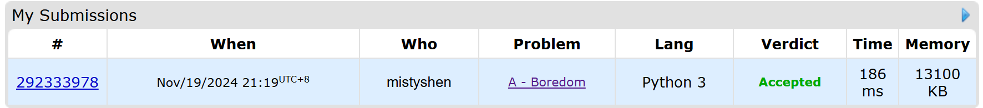

02287: Tian Ji -- The Horse Racing

greedy, dfs http://cs101.openjudge.cn/practice/02287

代码：

from bisect import bisect_left

while True:

n = int(input())

if n == 0:

break

tians = [int(x) for x in input().split()]

kings = [int(x) for x in input().split()]

tians.sort()

kings.sort()

ties = []

count = 0

for p1head in range(n):

a = bisect_left(kings,tians[p1head])

if a:

count += 1

kings.pop(a-1)

else:

ties.append(tians[p1head])

p2 = 0

for i in range(len(ties)):

if ties[i] < kings[p2]:

count -= 1

else:

p2 += 1

print(count*200)

代码运行截图 （至少包含有"Accepted"）

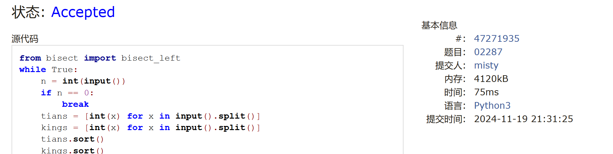

2. 学习总结和收获

（1）期中之后开始补算法部分的知识了，这次作业除了最后两个题都没有遇到太大困难，后面还需要学习dp和之前见过的背包问题。

（2）现在每天补做一些之前发布的练习题，感叹每天攒下来的东西居然有这么多